PTA Non-uniform day or
Halloween costumes
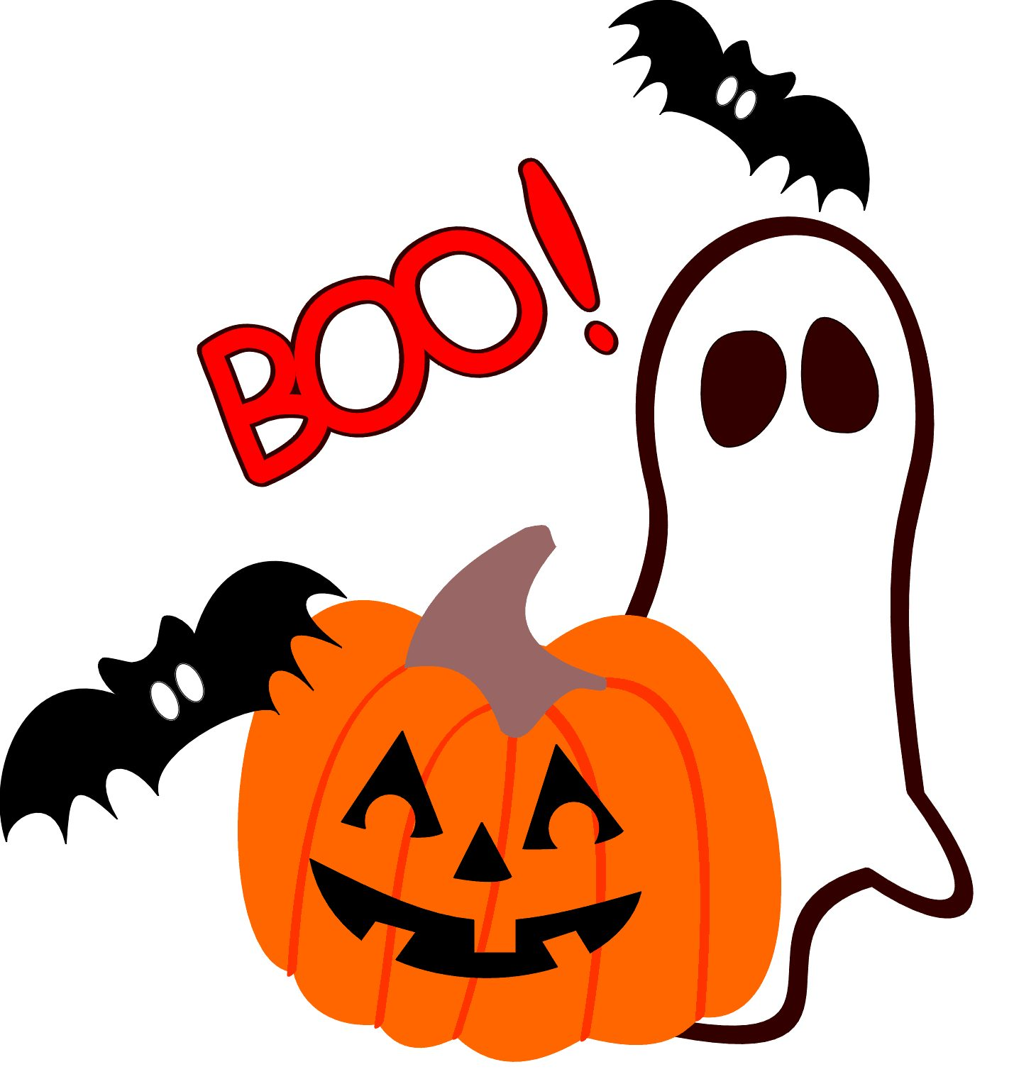
THURSDAY 22nd October
No scary masks please!

PTA will provide Trick or Treat sweets!
Cost £2.00 per child
Please pay via +Pay

